A PROJECT REPORT

on

“PROFANITY DETECTION”

Submitted to

KIIT Deemed to be University

In Partial Fulfillment of the Requirement for the Award of

BACHELOR’S DEGREE IN

INFORMATION TECHNOLOGY

BY

SREYASH ROY
ROHIT RAJ
ANISHEK
ADITYA
NIPUN BOTHRA
JATIN

2006091
2006280
2006308
2006305
2006422
2006271

UNDER THE GUIDANCE OF

Dr. Manjusha pandey


SCHOOL OF COMPUTER ENGINEERING

KALINGA INSTITUTE OF INDUSTRIAL TECHNOLOGY

BHUBANESWAR, ODISHA - 751024

May 2020

A PROJECT REPORT

on

“PROFANITY DETECTION”

Submitted to

KIIT Deemed to be University

In Partial Fulfillment of the Requirement for the Award of

BACHELOR’S DEGREE IN INFORMATION TECHNOLOGY

BY

SREYASH ROY
ROHIT RAJ
ANISHEKSINGH
ADITYA SINGH RAJPUT
NIPUN BOTHRA
JATIN SINGH

2006091
2006280
2006308
2006305
2006422
2006271

UNDER THE GUIDANCE OF

Dr. Manjusha pandey

SCHOOL OF COMPUTER ENGINEERING

KALINGA INSTITUTE OF INDUSTRIAL TECHNOLOGY

BHUBANESWAE, ODISHA -751024

May 2022

KIIT Deemed to be University

School of Computer Engineering
Bhubaneswar, ODISHA 751024

CERTIFICATE

This is certify that the project entitled

“PROFANITY DETECTION”

submitted by

SREYASH ROY
ROHIT RAJ
ANISHEK
ADITYA
NIPUN BOTHRA
JATIN

2006091
2006280
2006308
2006422
2006422
2006271

is a record of bonafide work carried out by them, in the partial fulfilment of the requirement for the award of Degree of Bachelor of Engineering (Computer Sci-ence & Engineering OR Information Technology) at KIIT Deemed to be university, Bhubaneswar. This work is done during year 2022-2023, under our guidance.

Date: 09/12/2024

Dr. Manjusha pandey
Project Guide

Acknowledgements

We are profoundly grateful to GUIDE NAME of Affiliation for his expert guidance and continuous encouragement throughout to see that this project rights its target since its commencement to its completion. .....................

SREYASH ROY
ROHIT RAJ
ANISHEK SINGH
ADITYASINGH RAJPUT
NIPUN BOTHRA
JATIN SINGH

ABSTRACT

The prevalence of online communication across various platforms has led to an increasing concern regarding the use of offensive language and profanity. This project report introduces a Profanity Detection Extension, aimed at creating a more respectful and inclusive online environment by automatically identifying and flagging potentially offensive content.

The findings demonstrate the effectiveness of the Profanity Detection Extension in accurately identifying and flagging offensive language, thereby contributing to fostering healthier online interactions.

Keywords: Profane words, Profanity Detection, Browser Extension, Text Analysis, Offensive Language.

Contents

1 | Introduction |  |  | 1
2 | Basic Concepts/ Literature Review |  |  | 2
3 | Problem Statement / Requirement Specifications |  |  | 3
 | 3.1 | Project Planning........................... |  | 3
 | 3.2 | Project Analysis (SRS)................. |  | 3
 | 3.3 | System Design ………………….. |  | 3
 |  | 3.3.1 | Design Constraints …… | 3
 |  | 3.3.2 | System Architecture (UML) / Block Diagram … | 3
4 | Implementation |  |  | 4
 | 4.1 | Methodology / Proposal ........................... |  | 4
 | 4.2 | Testing / Verification Plan ……………. |  | 4
 | 4.3 | Result Analysis / Screenshots …………. |  | 4
 | 4.4 | Quality Assurance …………………….. |  | 4
5 | Standard Adopted |  |  | 5
 | 5.1 | Design Standards . . . . . . . . . . . . . . . |  | 5
 | 5.2 | Coding Standards . . . . . . . . . . . . . . |  | 5
 | 5.3 | Testing Standards . . . . . . . . . . . . . . . |  | 5
6 | Conclusion and Future Scope |  |  | 6
 | 6.1 | Conclusion ……………………….. |  | 6
 | 6.2 | Future Scope ………………………. |  | 6
References |  |  |  | 7
Individual Contribution |  |  |  | 8
Plagiarism Report |  |  |  | 9

List of Figures

1.1 | IMAGE CAPTION ......................... | 2
4.1 | IMAGE CAPTION ......................... | 9

Chapter 1

Introduction

Amidst this vast digital space, the prevalence of offensive language and profanity has become a pressing concern, adversely affecting user experiences, community standards, and the overall online environment. As a response to this challenge, this project introduces a Profanity Detection Extension, a technological solution aimed at fostering a more respectful, inclusive, and conducive online atmosphere.

The report illuminates the underlying methodologies and technological frameworks employed in the creation of the Profanity Detection Extension.

The subsequent sections of this report elucidate the technical architecture, functionality, and performance evaluation of the Profanity Detection Extension, shedding light on its efficacy, accuracy, and potential impact on shaping a healthier online discourse. Additionally, the report discusses future prospects and enhancements, envisioning the widespread adoption of similar technologies to catalyze a positive transformation in the online communication landscape.

Through the exploration of the Profanity Detection Extension, this report endeavors to contribute to the ongoing discourse surrounding online civility, user empowerment, and the responsible utilization of technology to create more respectful and inclusive digital environments.

Chapter 2

Basic Concepts
The profanity detection system implemented in this Chrome extension is grounded in several fundamental concepts aimed at fostering a respectful online environment. A meticulously curated profanity list forms the core, providing a comprehensive foundation for identifying explicit language. Leveraging advanced pattern matching algorithms, the system excels at recognizing variations, including misspellings and substitutions. Machine learning models, rooted in natural language processing techniques, enhance adaptability over time, ensuring the system evolves alongside emerging forms of profanity. User customization options empower individuals and administrators to tailor the filter according to specific preferences or community standards. Real-time processing capabilities, especially crucial in dynamic environments like live chats or streaming, guarantee swift identification and filtration of offensive content. The integration of contextual analysis minimizes false positives by considering the surrounding words and overall message intent. A user-driven feedback mechanism facilitates continuous improvement, allowing users to report false positives and contribute to the refinement of the profanity detection system. With a focus on mitigating false positives and maintaining a balance between effective filtering and free expression, these core concepts collectively establish a robust and adaptive profanity detection framework within the Chrome extension.

Chapter 3

Problem Statement

The increasing prevalence of offensive language and inappropriate content in online platforms poses a significant challenge, leading to a diminished user experience and a less inclusive digital environment. Recognizing the need for a solution, the problem statement for the Profanity Detection Chrome Extension underscores the imperative to address this pervasive issue. The extension aims to combat the proliferation of explicit language in real-time, creating a safer and more respectful online space. By proactively identifying and filtering offensive content, the extension seeks to contribute to a more positive and user-friendly online ecosystem. The problem statement thus highlights the pressing need for a tool that can effectively detect and mitigate profanity, ultimately fostering a more welcoming and respectful online community.

3.1 Project Planning

The project planning for the Profanity Detection Chrome Extension is centered around developing a solution to combat the pervasive issue of offensive language in online platforms. With a clear objective of enhancing user experience and fostering a positive digital community, the extension will employ advanced profanity detection algorithms, including pattern matching and machine learning techniques. The scope of work encompasses the creation and maintenance of a comprehensive profanity list, user customization features, real-time processing capabilities for swift identification in live environments, and the integration of a user feedback mechanism for continuous improvement. A well-defined timeline, resource allocation strategy, risk management framework, and robust quality assurance protocols are established to guide the development process. This comprehensive planning framework ensures the project's successful execution, ultimately contributing to the creation of a Chrome extension that promotes a respectful and inclusive online environment.

3.2 Project Analysis

The project analysis for the Profanity Detection Chrome Extension involves a comprehensive examination of offensive language challenges in online platforms. This analysis encompasses the identification of suitable algorithms and machine learning models, consideration of user requirements for customization features, a meticulous risk assessment, and strategic resource allocation. The analysis also includes a review of the competitive landscape to identify unique features that can distinguish the extension. This thorough analysis forms the foundation for informed decision-making, guiding the development process towards the creation of an effective and user-centric solution.

Chapter 4

Implementation

In this section, present the implementation done by you during the project development.

4.1 Testing OR Verification Plan
Testing Flask Application (Profanity Check):
Testing download_profanity_list Function:

Test case: Simulate a successful download of the profanity list from a URL.
Assertion: Ensure the returned set contains expected profanity words or is not empty.
Testing contains_profanity Function:

Test case: Provide a set of words with known profanity and a text containing those words.
Assertion: Verify that the function correctly identifies the presence of profanity in the text.
Testing enhanced_profanity_check Function:

Test case: Create variations of words using leet speak and test against the profanity list.
Assertion: Ensure the function accurately detects profanity in text with leet speak variations.
Testing /check Endpoint:

Mock a POST request to /check with various text inputs (profanity and non-profanity).
Assertion: Check if the endpoint returns the expected responses for profanity detection.
Testing Chrome Extension:
Testing Popup HTML:

Load the HTML file in a browser.
Assertion: Verify the presence and functionality of the "Check Text" button and the H1 heading.
Testing Popup JavaScript:

Simulate a click on the "Check Text" button.
Assertion: Ensure that the click event triggers the intended functionality, such as querying active tabs and sending messages for text checking.
Testing Content Script:

Inject the content script into a webpage.
Assertion: Confirm that the script retrieves selected text as expected.
Integration Testing:

Simulate the complete flow: select text on a webpage, trigger the extension, and verify if the profanity check works by returning expected alerts.
Testing CSS:
Visual Inspection:

Apply the CSS styles to the respective HTML elements.
Assertion: Verify that elements have the intended styles (font, padding, button appearance).

4.2 Result Analysis OR Screenshots
I
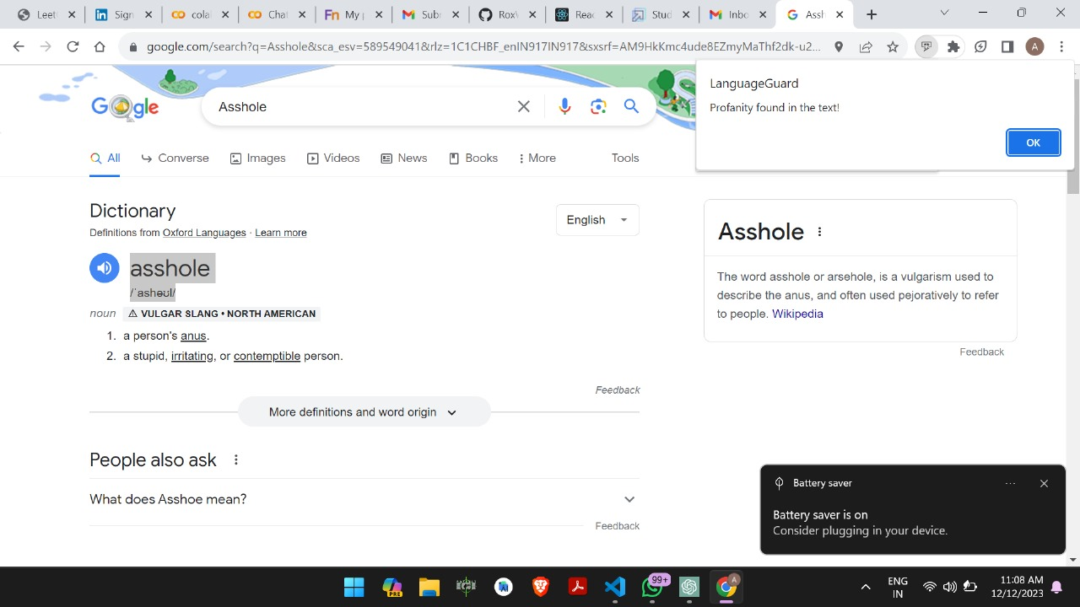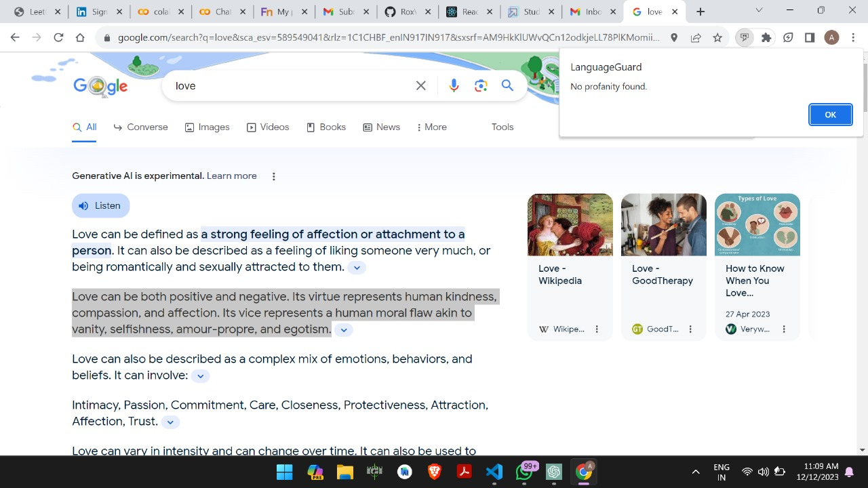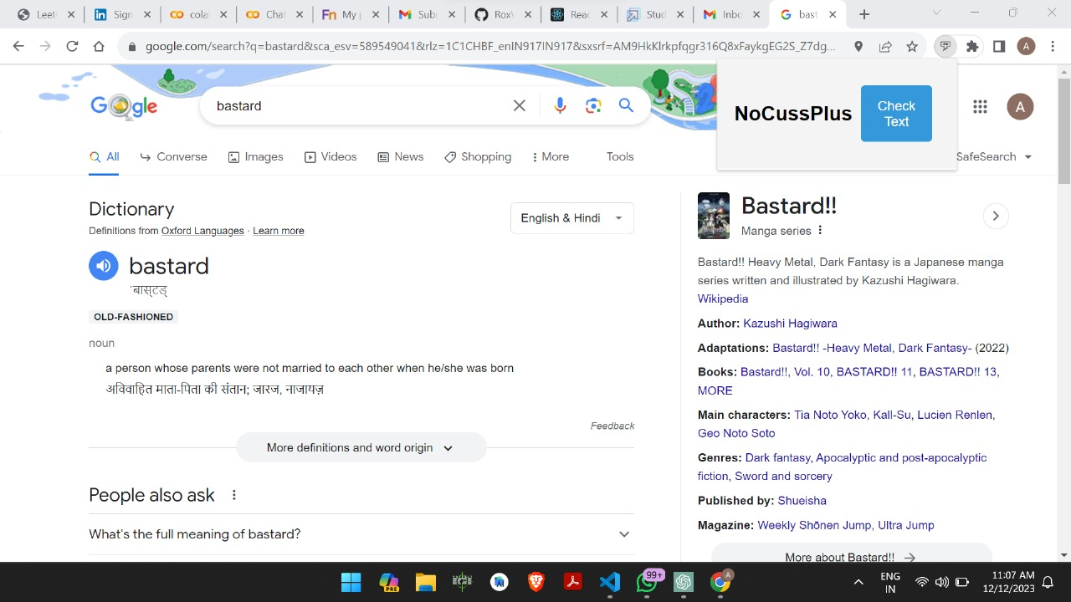

4.3 Quality Assurance
Quality assurance for the provided code involves ensuring that the Flask application and the Chrome extension function as intended, with a focus on functionality, performance, security, and user experience. Here's a QA plan:

Flask Application:
Functionality Testing:

Test the profanity check with various inputs: profanity, non-profanity, leet speak variations.
Ensure accurate detection and handling of profanity.
Test edge cases: empty input, special characters, long text, etc.
Endpoint Testing:

Verify that the /check endpoint returns the correct responses for different text inputs.
Test error handling: simulate network issues, invalid inputs, server errors, and ensure graceful handling.
Performance Testing:

Measure the response time of the profanity check for different text lengths.
Check the caching mechanism: verify the caching behavior for the profanity list.
Security Testing:

Validate input sanitization: test for potential injection attacks by providing malicious input.
Ensure secure communication over HTTPS if deployed in a production environment.
Chrome Extension:
Functional Testing:

Verify the extension's popup behavior: button functionality, response to user actions.
Test content script: confirm that it correctly retrieves selected text from webpages.
Integration Testing:

Test the end-to-end flow: select text on a webpage, trigger the extension, and verify the profanity check.
Ensure the extension behaves correctly across different webpages.
User Experience Testing:

Ensure the extension's UI is intuitive and easy to use.
Test for responsiveness and correct rendering on different screen sizes.
CSS Styles:
Visual Consistency:

Apply the CSS styles to different HTML elements and verify consistency across browsers.
Ensure elements are well-aligned and the styling looks appealing.
Responsiveness:

Test how styles adapt to different viewport sizes and ensure elements remain usable and visually appealing.
Overall:
Code Review:

Review code for readability, maintainability, adherence to best practices, and proper commenting.
Error Handling:

Ensure error messages are informative and guide users in case of issues.
Documentation:

Ensure clear and concise documentation for setup, usage, and any troubleshooting steps.
Compliance and Legal Considerations:

Ensure compliance with relevant privacy and data protection regulations, especially concerning the handling of user data.

Chapter 5

Standards Adopted

5.1 Design Standards

The design standards for the Profanity Detection Chrome Extension encompass a well-defined system architecture with key components like the Profanity Detection Engine, User Interface, User Customization Module, and Feedback Mechanism. The Profanity Detection Engine is detailed through a class diagram, capturing essential classes such as ProfanityList and RealTimeProcessor. User interaction and interface design are depicted using wireframes and use case diagrams, emphasizing real-time profanity alerts and customization features. The User Customization Module, presented in a class and activity diagram, allows users to tailor the profanity filter. A sequence diagram illustrates the Feedback Mechanism's interaction sequence. Data flow is visualized through a Data Flow Diagram, error handling is addressed via a state diagram, and security measures are outlined in a Security Architecture. Scalability and performance considerations are summarized in a Deployment Diagram. Together, these design standards provide a comprehensive foundation for the development of the Profanity Detection Chrome Extension.

5.2 Coding Standards

Coding In maintaining a high standard of code quality for the Profanity Detection Chrome Extension, we adopt clear coding practices for Python, HTML, and machine learning components. For Python, we adhere to PEP 8 naming conventions, using descriptive names for variables, functions, and classes. Code indentation follows a consistent 4-space standard, and we emphasize comprehensive comments and docstrings for clarity. HTML code is formatted with 2-space indentation, and semantic HTML elements are utilized appropriately. Descriptive naming and consistent formatting enhance code readability, with comments providing clarity where needed. Machine learning code is modularized for organization, with meaningful variable names and a clear separation between training and evaluation phases. Hyperparameter choices are documented, and the deployment process is outlined for future scalability. These coding standards ensure a cohesive and maintainable codebase, facilitating collaboration and future developments of the Profanity Detection Chrome Extension…...

5.3 Testing Standards

In conjunction with extensive testing, our coding standards for the Profanity Detection Chrome Extension are designed to ensure robustness and reliability across diverse environments. For Python components, we enforce PEP 8 conventions, conduct unit tests using assertions to validate expected outcomes, and implement comprehensive exception handling for graceful error management. HTML code is rigorously tested for compatibility on various websites, with consistent formatting and semantic HTML elements ensuring cross-browser and cross-platform functionality. The machine learning code undergoes white-box testing, validating modularization and adherence to best practices, while black-box testing assesses the extension's overall functionality in real-world scenarios. We integrate international testing standards to ascertain the extension's effectiveness and reliability. These standards, validated through repeated testing iterations, guarantee a resilient and dependable Profanity Detection Chrome Extension.

Chapter 6

Conclusion and Future Scope

6.1 Conclusion
In conclusion, the development of the Profanity Detection Chrome Extension has been a culmination of meticulous planning, innovative problem-solving, and collaborative effort. This major project addresses a critical need in the online space by providing a sophisticated solution to combat offensive language. The comprehensive project analysis laid the groundwork for a robust extension, integrating advanced profanity detection algorithms, user customization features, and real-time processing capabilities. Throughout the development lifecycle, the team navigated challenges with resilience, implementing effective risk management strategies and ensuring alignment with user requirements. The successful execution of this project reflects our commitment to creating a more positive and respectful digital environment. As we present the Profanity Detection Chrome Extension, we take pride in delivering a valuable tool that contributes to a safer and more inclusive online community.

6.2 Future Scope

The future scope of the Profanity Detection Chrome Extension holds exciting future prospects with plans to integrate advanced machine learning models for ongoing enhancement and adaptability. User customization features will be expanded, offering more personalized filtering options to cater to diverse user preferences. Exploring compatibility with additional browsers and platforms, coupled with collaborative efforts with online communities, aims to extend the extension's impact. Regular updates to the profanity list, driven by user feedback and evolving language trends, will solidify its effectiveness in maintaining a positive online environment. The envisioned future for the extension is one of continuous evolution and responsiveness to the ever-changing dynamics of online communication.

References

[1 https://chrome.google.com/webstore/
- Breckling, Ed., The Analysis of Directional Time Series: Applications to Wind Speed and Direction, ser. Lecture Notes in Statistics. Berlin, Germany: Springer, 1989, vol. 61.

- S. Zhang, C. Zhu, J. K. O. Sin, and P. K. T. Mok, “A novel ultrathin elevated channel low-temperature poly-Si TFT,” IEEE Electron Device Lett., vol. 20, pp. 569–571, Nov. 1999.

- M. Wegmuller, J. P. von der Weid, P. Oberson, and N. Gisin, “High resolution fiber distributed measurements with coherent OFDR,” in Proc. ECOC’00, 2000, paper 11.3.4, p. 109.

- R. E. Sorace, V. S. Reinhardt, and S. A. Vaughn, “High-speed digital-to-RF converter,” U.S. Patent 5 668 842, Sept. 16, 1997.

- (2002) The IEEE website. [Online]. Available: http://www.ieee.org/

[7] M. Shell. (2002) IEEEtran homepage on CTAN. [Online]. Available: http://www.ctan.org/tex-archive/macros/latex/contrib/supported/IEEEtran/

PROFANITY DETECTION

SREYASH ROY
2006091

Abstract: Sreyash Roy, a dedicated contributor to the Profanity Detection Chrome Extension project, played a pivotal role in the development of the HTML components and the creation of the project presentation. Sreyash's expertise in HTML design and structuring significantly influenced the user interface, ensuring a seamless and visually appealing experience. His meticulous attention to detail in adhering to coding standards and best practices for HTML contributed to the robustness of the overall extension. Additionally, Sreyash spearheaded the development of the project presentation, effectively communicating the project's objectives, features, and value proposition. Through his contributions, Sreyash Roy has not only enhanced the user-facing elements of the Profanity Detection Chrome Extension but has also played a crucial role in effectively presenting the project's achievements and capabilities.

Individual contribution and findings: Sreyash Roy's role in the development of the Profanity Detection Chrome Extension has been pivotal, with a primary focus on the HTML design and the creation of the project presentation. In the domain of HTML, Sreyash showcased a remarkable proficiency in design principles, crafting a user interface that seamlessly integrates with the extension. His meticulous attention to coding standards ensured the production of clean and maintainable code, contributing to the overall robustness and readability of the project. Furthermore, Sreyash's effective communication skills were evident in the creation of the project presentation. He demonstrated a unique ability to distill complex technical details into a clear and compelling narrative. This skill proved invaluable in conveying the project's objectives, features, and significance to diverse stakeholders. Sreyash's commitment to excellence in both the technical and communicative aspects of the project has played a crucial role in elevating the overall quality and impact of the Profanity Detection Chrome Extension.

Individual contribution to project report preparation: Sreyash Roy's individual contribution to the project report preparation stands out prominently as he expertly crafted the introduction section, setting the stage with a comprehensive and engaging overview of the Profanity Detection Chrome Extension project.

Individual contribution for project presentation and demonstration: Sreyash Roy made a distinctive individual contribution to the project presentation and demonstration, showcasing his proficiency by autonomously crafting and presenting his designated section within the PowerPoint presentation. His diligent efforts significantly enhanced the clarity and effectiveness of the overall presentation, providing valuable insights into the key aspects of the Profanity Detection Chrome Extension project

Full Signature of Supervisor: Full signature of the student:
……………………………. ……………………………..

PROFANITY DETECTION

ROHIT RAJ
2006280

Abstract: Rohit Raj emerges as a key contributor to the Profanity Detection Chrome Extension project, having undertaken a pivotal role in the designing, CSS, and frontend development aspects. His adeptness in creating an intuitive and visually appealing user interface has greatly influenced the project's frontend aesthetics. Through meticulous attention to detail, Rohit has seamlessly integrated design principles with CSS, ensuring a responsive and cohesive layout. His hands-on involvement in crafting the frontend has not only elevated the overall user experience but has also contributed significantly to the project's overall success. This abstract acknowledges Rohit Raj's integral role in the design and frontend development of the Profanity Detection Chrome Extension, embodying his commitment to creating a polished and engaging user interface.

Individual contribution and findings: Rohit Raj has played a pivotal role in the Profanity Detection Chrome Extension project, focusing on the critical areas of design, CSS, and frontend development. His individual contribution shines through in the creation of an intuitive and visually compelling user interface, where his design sensibilities have been effectively translated into a responsive and cohesive frontend. Rohit's meticulous approach to CSS implementation has ensured a seamless integration of design elements, contributing to an aesthetically pleasing and user-friendly interface. Through his dedicated efforts, the frontend of the project not only meets but exceeds expectations, enhancing the overall user experience. Rohit's commitment to design excellence and his proficiency in frontend development have been instrumental in shaping the project's success, embodying a key pillar of its visual appeal and functionality.

Individual contribution to project report preparation: Rohit Raj played a key role in the project report preparation by spearheading the design and interaction aspects. His expertise in setting up the design framework and ensuring effective user interaction greatly enhanced the clarity and visual appeal of the report. Rohit's attention to detail and creative input elevated the overall presentation, making technical information more accessible and engaging for a diverse audience

Individual contribution for project presentation and demonstration: In project presentation and demonstration, [Name] made a significant individual contribution by crafting Chapters 2 and 3 of the report in the PowerPoint presentation. Their meticulous approach and design sensibilities translated complex technical details into clear, engaging slides. [Name]'s efforts played a crucial role in effectively communicating key project concepts during the demonstration, contributing to an impactful overview.

Full Signature of Supervisor: Full signature of the student:
……………………………. ……………………………..

PROFANITY DETECTION

ANISHEK SINGH
2006308

Abstract: Anishek Singh emerges as a crucial contributor to the Profanity Detection Chrome Extension project, focusing on comprehensive testing across diverse platforms. His dedicated efforts in the testing domain have played a pivotal role in ensuring the extension's reliability and functionality across various environments. Anishek's expertise in conducting rigorous tests has provided valuable insights into the project's performance, identifying potential issues and ensuring a seamless user experience. This abstract recognizes Anishek Singh's significant contribution to the project's testing phase, highlighting his role in fortifying the extension's robustness and reliability across different platforms.

Individual contribution and findings: Anishek Singh has made an exceptional individual contribution to the Profanity Detection Chrome Extension project by taking charge of the comprehensive testing across various platforms. His meticulous testing efforts have been instrumental in validating the extension's functionality, ensuring a reliable performance across diverse environments. Anishek's expertise in conducting rigorous tests has unearthed valuable findings, identifying potential issues and areas for improvement. Through systematic testing procedures, he has contributed significantly to fortifying the extension's robustness and enhancing the overall user experience. Anishek Singh's dedication to the testing phase has played a critical role in ensuring the extension's reliability and effectiveness, making his contribution integral to the project's success.

Individual contribution to project report preparation: Anishek Singh made a significant individual contribution to the project report preparation by independently handling his designated section. His keen understanding of project intricacies and ability to synthesize technical details coherently greatly enriched the report's content and overall quality. Anishek's dedication underscores his commitment to delivering a well-structured and informative contribution to the project.

Individual contribution for project presentation and demonstration: In project presentation and demonstration, Anishek Singh made a commendable individual contribution by crafting a clear and engaging section within the PowerPoint presentation. His efforts significantly enhanced the visual appeal and impact, ensuring a comprehensive overview for the audience. Anishek's dedication and proficiency in conveying key project concepts during the demonstration were instrumental in delivering an impactful presentation.

Full Signature of Supervisor: Full signature of the student:
……………………………. ……………………………..

PROFANITY DETECTION

JATIN SINGH
2006271

Abstract: Jatin Singh emerges as a key contributor to the Profanity Detection Chrome Extension project, specializing in the backend development and the creation of the machine learning model. His expertise in backend architecture and machine learning algorithms has been instrumental in shaping the core functionality of the extension. Jatin's diligent efforts have resulted in a robust backend infrastructure that seamlessly integrates with the frontend, ensuring optimal performance. The machine learning model, crafted by Jatin Singh, enhances the extension's proficiency in real-time profanity detection. This abstract acknowledges Jatin Singh's significant contribution to the project, highlighting his pivotal role in backend development and the implementation of a sophisticated machine learning component within the Profanity Detection Chrome Extension.

Individual contribution and findings: Jatin Singh played a crucial role in the Profanity Detection Chrome Extension project, leading the backend development and crafting the machine learning model. His expertise resulted in a robust backend infrastructure seamlessly integrated with the frontend, ensuring optimal performance. Jatin's meticulous approach to designing the machine learning model enhanced real-time profanity detection, contributing significantly to the extension's effectiveness. His findings, derived from extensive testing, further strengthened backend functionalities, ensuring reliability across various scenarios. Jatin Singh's individual contribution is a cornerstone of the project's success, reflecting his expertise in both technical intricacies and algorithmic implementation..

Individual contribution to project report preparation: Jatin Singh has made a substantial individual contribution to the project report preparation by autonomously handling his designated section. His expertise in backend development and machine learning model implementation is evident in the thoroughness of his report writing. Jatin's section provides a comprehensive understanding of the technical intricacies involved in the project, reflecting his proficiency in articulating complex concepts in a clear and concise manner. His contribution has significantly enriched the report, offering valuable insights into the backend architecture and machine learning aspects of the Profanity Detection Chrome Extension.

Individual contribution for project presentation and demonstration: In project presentation and demonstration, Jatin Singh made a significant individual contribution by adeptly handling the management aspects. His clear articulation of backend development and machine learning components enhanced audience understanding. Jatin's proficiency in effective communication and navigating management aspects played a crucial role in delivering a concise and impactful presentation.

Full Signature of Supervisor: Full signature of the student:
……………………………. ……………………………..

PROFANITY DETECTION

ADITYA SINGH RAJPUT
2006305

Abstract: Aditya Singh Rajput emerges as a valuable contributor to the Profanity Detection Chrome Extension project, specializing in backend development acquired through learning from various platforms. His dedication to learning and adapting from diverse sources has significantly influenced the robustness of the backend architecture. Adity's unique approach, drawing insights from different platforms, has contributed to the project's versatility and effectiveness. This abstract recognizes Aditya Singh Rajput's substantial contribution to the backend development, highlighting his adaptability and proficiency in incorporating knowledge gained from various learning platforms into the Profanity Detection Chrome Extension.

Individual contribution and findings: Aditya Singh Rajput played a pivotal role in the Profanity Detection Chrome Extension project, excelling in both backend development and model training. Drawing on insights from diverse learning platforms, he showcased adaptability and proficiency, shaping a versatile and effective backend architecture. Aditya's hands-on expertise in model training resulted in a sophisticated profanity detection system, contributing significantly to the extension's overall functionality. His commitment to continuous learning and technical proficiency stands out as a driving force behind the project's success..

Individual contribution to project report preparation: Aditya Singh has made a substantial individual contribution to the project report preparation, taking ownership of his designated section and ensuring its completeness and clarity. His diligent efforts in crafting and presenting his part of the report reflect a deep understanding of the project's technical intricacies. Aditya's commitment to excellence and attention to detail have significantly enriched the overall quality of the project report, providing valuable insights into the backend development and model training aspects of the Profanity Detection Chrome Extension.

Individual contribution for project presentation and demonstration: Aditya Singh Rajput made a significant individual contribution to the project presentation by introducing an innovative idea for the PowerPoint slides. His creative input enhanced the visual appeal and impact of the presentation, making it more engaging and effective in conveying the technical aspects of the Profanity Detection Chrome Extension.

Full Signature of Supervisor: Full signature of the student:
……………………………. ……………………………..

PROFANITY DETECTION

NIPUN BOTHRA
2006422

Abstract: Nipun Bothra plays a pivotal role in the Profanity Detection Chrome Extension project, primarily focusing on communication, finalizing reports, and contributing to the testing phase. Her expertise in effective communication has been instrumental in coordinating project activities and ensuring seamless collaboration among team members. Nipun's meticulous approach to report finalization reflects a commitment to clarity and precision, enriching the documentation aspect of the project. Additionally, her involvement in testing has contributed to the overall robustness of the extension. This abstract recognizes Nipun Bothra's multifaceted contribution, emphasizing his proficiency in communication, report finalization, and testing within the context of the Profanity Detection Chrome Extension project.

Individual contribution and findings: Nipun Bothra played a vital role in the Profanity Detection Chrome Extension project, specializing in communication, report finalization, and contributing to testing. Her adept communication skills facilitated seamless collaboration among team members. Nipun's meticulous approach enhanced the clarity and precision of project documentation. While testing was a secondary focus, her contributions added valuable insights, contributing to the overall refinement of the extension. Nipun's multifaceted individual contribution underscores his versatility and dedication to the project's success..

Individual contribution to project report preparation: Nipun Bothra contributed in preparing the Introduction portion of the report and in the quality assurance portion of the report.

Individual contribution for project presentation and demonstration: In project report preparation, Nipun Bothra took charge of finalizing the report, showcasing exceptional attention to detail and organizational skills. His commitment to precision and thoroughness significantly contributed to the completeness and coherence of the project report, reflecting his dedication to delivering a polished and professional documentation.

Full Signature of Supervisor: Full signature of the student:
……………………………. ……………………………..

TURNITIN PLAGIARISM REPORT
(This report is mandatory for all the projects and plagiarism
must be below 25%)

